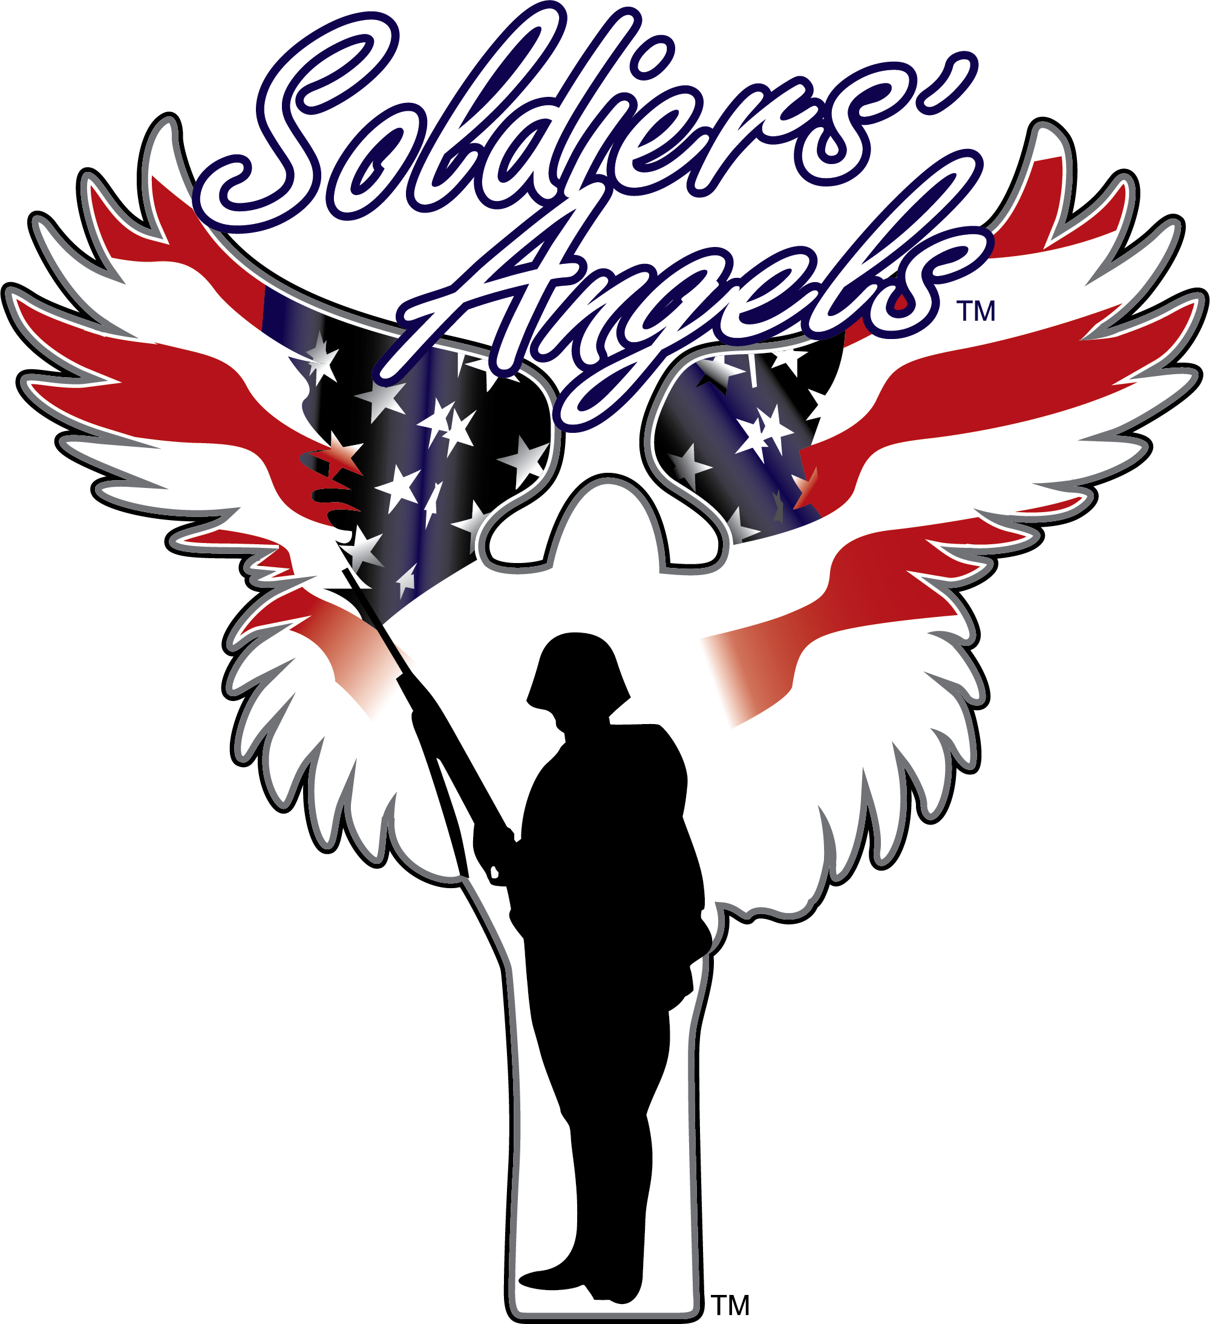
FOR IMMEDIATE RELEASE: [Insert Date]
MEDIA CONTACT: Mark Szymanski
Email: mark.szymanski@evocatillc.com

FOR IMMEDIATE RELEASE

[Business Name] Joins Soldiers’ Angels in Valentine’s for Veterans Program, Extends Heartfelt Support
Drop Off Valentine’s Day cards for Veterans in VA Hospitals, deployed Service Members at our location(s)

[CITY, State] – Embracing the spirit of compassion and gratitude, [Business Name] proudly announces its participation in the renowned Soldiers’ Angels Valentine’s for Veterans program. This initiative aims to collect heartfelt Valentine’s Day greeting cards for both deployed Service Members and Veterans receiving care in VA Hospitals across the nation.

[Business Name] is thrilled to stand alongside Soldiers’ Angels in this heartfelt endeavor, actively contributing to the collection of Valentine’s Day cards. Our establishment firmly believes in the power of small gestures to make a monumental impact in the lives of those who serve our country.

[Adjust or rewrite this quote to match your brand language] “As a proud supporter of our military community, we are honored to be part of Soldiers’ Angels Valentine’s for Veterans program,” expressed [Business Representative]. “This initiative aligns perfectly with our values of gratitude and support for our Service Members and Veterans.”

Soldiers’ Angels CEO, Amy Palmer, a distinguished U.S. Air Force Veteran, emphasizes the significance of these gestures. “To our deployed Service Members, receiving a simple greeting card holds immeasurable value, offering them a connection to home and a reminder of our unwavering support,” remarked Palmer. “Similarly, for our Veterans in VA Hospitals, a heartfelt card symbolizes the appreciation and care they rightfully deserve.”

[Business Name] encourages everyone eager to share love and appreciation this Valentine’s Day to contribute to this noble cause. Whether store-bought or handmade, individuals can drop off their heartfelt greeting cards at [Business Address] from [Start Date] to [End Date].

Join us in spreading joy and appreciation to our courageous Service Members and honorable Veterans. Let us unite in making this Valentine’s Day a momentous occasion for those who have dedicated their lives to our nation’s service.

For inquiries or further information, please contact [Business Contact Information].

For more information on the program, visit: https://soldiersangels.org/valentinesforveterans/

About Soldiers’ Angels: Soldiers' Angels is a national 501(c)(3) nonprofit that provides aid, comfort, and resources to the Military, Veterans, and their families. Founded in 2003 by the family of General George Patton, hundreds of thousands of Soldiers' Angels "Angel" volunteers assist Veterans, wounded and deployed personnel and their families in a variety of unique and effective ways. (Tax ID# 20-0583415, CFC# 25131). Learn more at soldiersangels.org.

